Symbiosis Skills and Professional University



Skill Journal

**Name:** Yograj Anant Gadekar **Date:10-12-2021**

**PRN:**

**School:** School of Data Science

**Course:** Data Associate (Data Science)

**Module Name:** Python for Data Analysis **/** Managing with Data **/** Analyzing Data from Disparate Sources **(tick any one)**

1. **Skill Activity Number: 9**
2. **Title: Business** Analytics on PUBG Game Data Analysis
3. **Skills / Competencies to be acquired:**

Python

1. **Duration:** 2 days
2. **What is the purpose of the activity?**

How to analyses, explore a data with Python

1. **Steps Performed in this activity?**
2. **What resources / materials / equipment / tools did you use for this activity?**

Jupyter Notebook, MS Word

1. **What skills did you acquire?**

Python

1. **Time taken to complete this activity?**

2 Hours

**Business – Analytics Assignment on Project Data**

**Project: PUBG Game Data Analysis**

1. **Descriptive Analytics:**

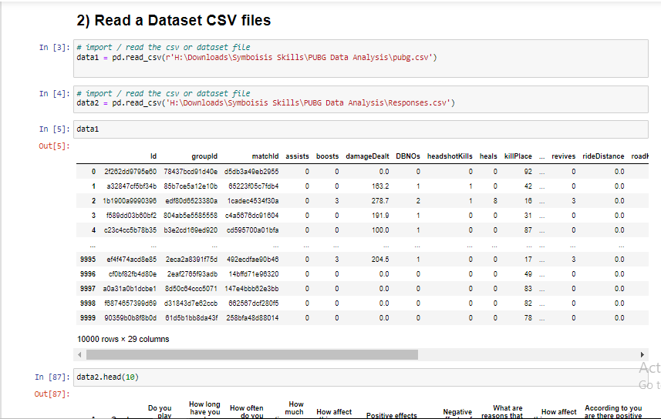

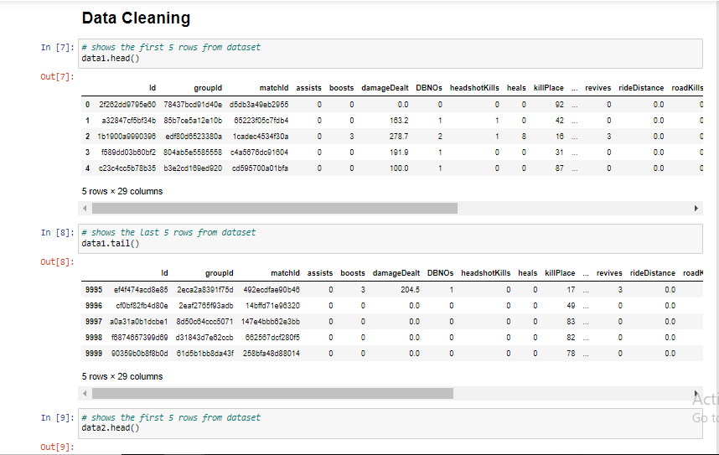

# 

### **The most kills ever recorded are**

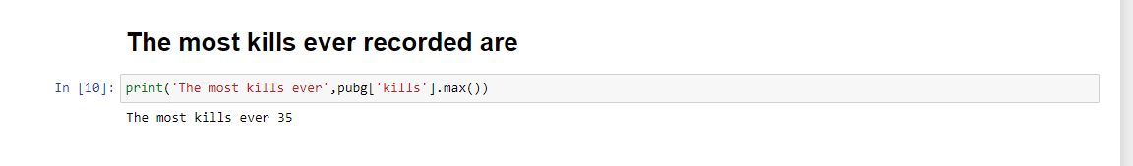

### **Min, Max Median values of kills, killPoints, Age**

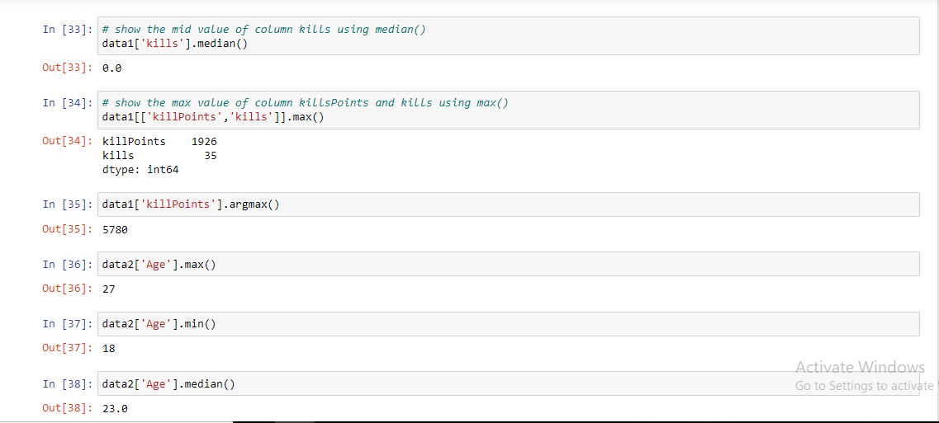

### **Finding Rank Points of players where points are greater than 2000**

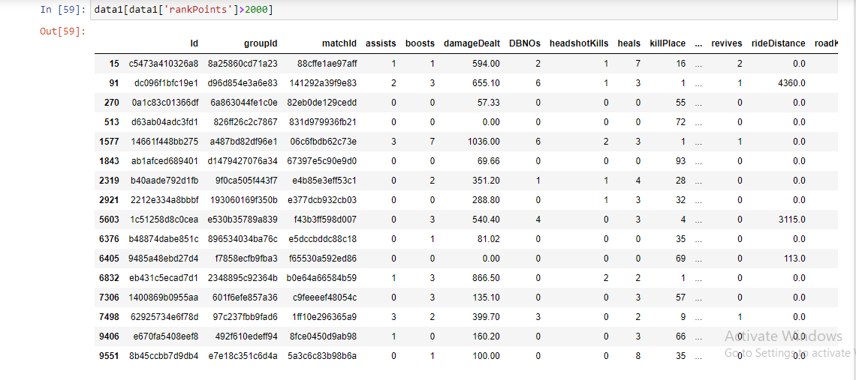

### **Counting of Match Type in Game**

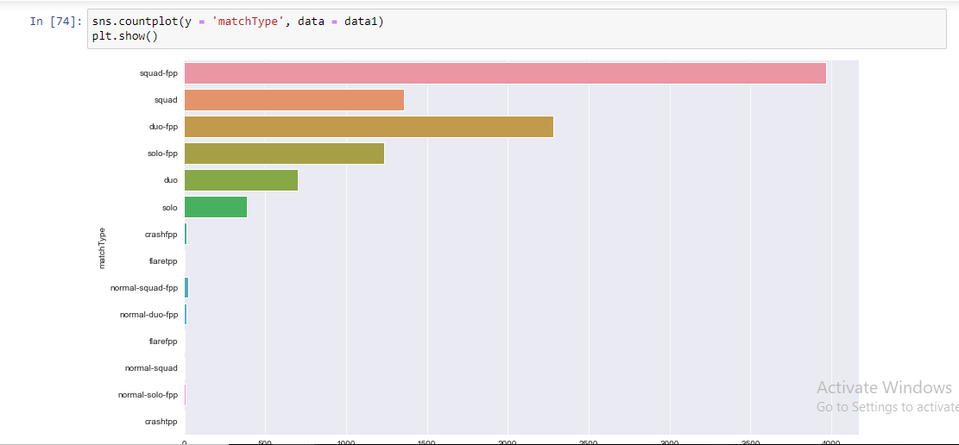

1. **Distribution of Match duration vs walk distance**

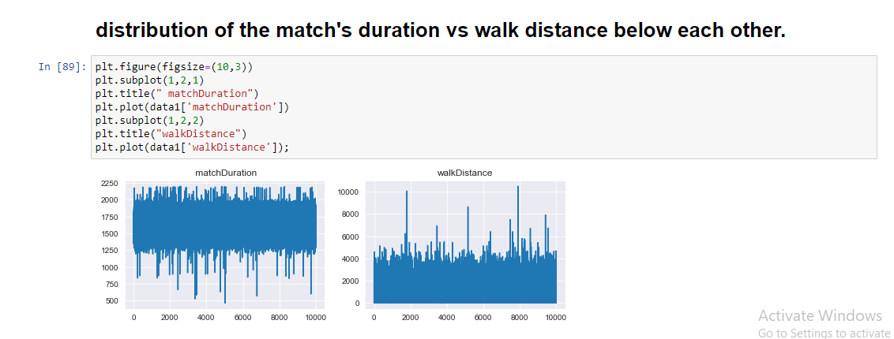

1. **Calculate age groups by using pubg_dataset.**

sns.countplot(x = 'Age', data = data2)

plt.show()

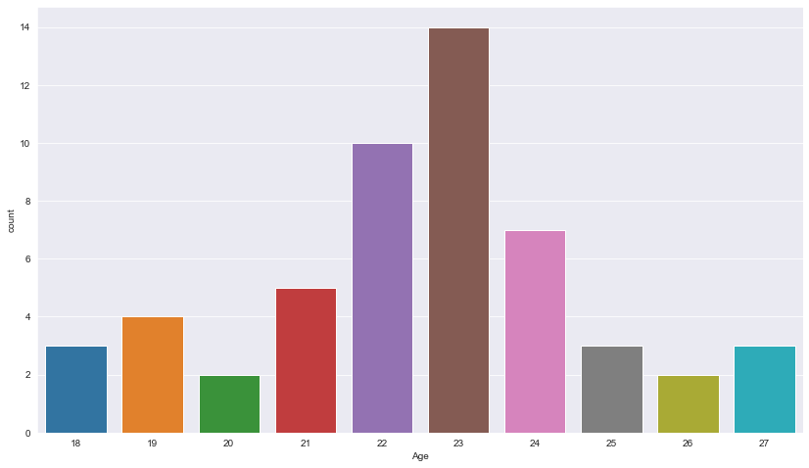

# **Calculating What are reasons that you don’t play PUBG?**

sns.countplot(y = 'What are reasons that you dont play PUBG', data = data2)

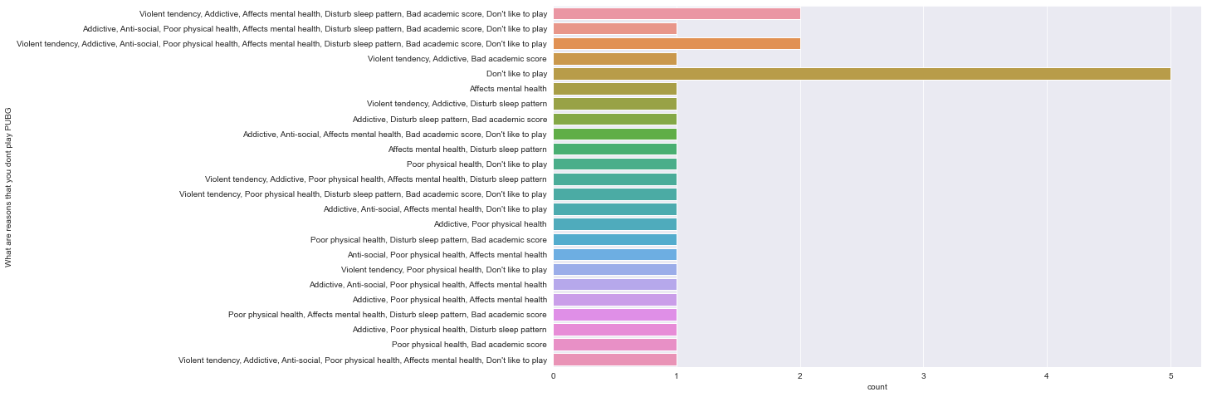 plt.show()

# **Visualize headshotKills & weaponsAcquired by using scatter plot.**

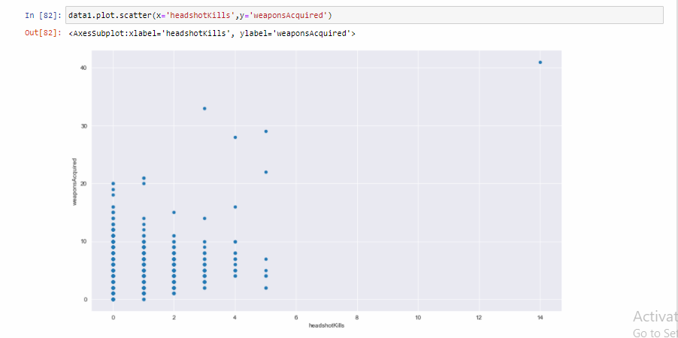

### **How many unique values are there in 'matchType' and what are their counts?**

1. **Diagnostic Analytics:**

PUBG Game:

1. It happens because of Gaming addiction.

2. Due to this pandemic situation peoples are played PUBG game.

**3) Predictive Analytics:**

1. Age wise side effects count.

2. It affects on our physical health

**4) Prescriptive Analytics:**

1. Control any addiction by proper measures.

2. To begin with, try to lessen the time you spend on the game.

3. Try to divert your mind. Do not always stay indoors. Go out

and indulge in physical activities.